1. Describe/discuss/explain what is meant by the term *conducting airways*.

Conducting airways provide a path for air between the atmosphere and the gas exchange units (the alveoli). No gas exchange (i.e., O2, CO2) occurs between air in the conducting airways and pulmonary capillary blood (B&L[7], page 436; Vander[14], pages 443 - 444; West[10, pages 2 - 3 and Figures 1.4 and 1.5).

Explain the physiological function(s) of the conducting airways.

The upper conducting airway also serves to warm and humidify entering (inspired) air (B&L[7], page 434) and to remove particulates from the inspired air. The remainder of the conducting airways also serve to remove particulates from the inspired air.

1. Describe/discuss/explain the respiratory function(s) of the nose.

The nose also functions to filter, entrap, and clear particles larger than 10 μm in size. The interior of the nose is lined by respiratory epithelial cells interspersed with surface secretory cells. These secretory cells produce important immunoglobulins, inflammatory mediators, and interferons, which are the first line of host defense. The nose also is part of the upper airways which “condition” inspired air so that by the time air reaches the trachea, inspired air is at body temperature and fully humidified.

1. Describe/discuss/explain how (mechanism(s)) particulates in atmospheric air are removed before they reach the alveoli; describe/discuss/explain the fate of such particulates that do reach the alveoli.

Particulates in air inhaled through the nose can be trapped in nose hair or can be trapped in nasal mucus, either by direct impact or by settling out subsequent to flow stagnation caused by turbulent flow as a result of inlet air impacting the nasal turbinates. Particulates making it further down the respiratory tree can be trapped in airway mucus; these trapped particulates are moved towards the mouth (to be expectorated or swallowed) by cilia that form a “mucus escalator” (B&L[7], pages 498 - 501; West[10], page 10 and chapter 9. Particulates that reach the alveoli can be cleared by lymphatic drainage and/or by being phagocytized by alveolar macrophages. (B&L[7] page 501; West[10], page 10 and chapter 9; video 2, slide 8.

1. What is the driving force for the movement of oxygen from alveolar air into the pulmonary capillaries?

In alveolus PO2 ≈ 100mmHg, in the blood coming back from the tissue into the pulmonary capillary, PO2 ≈ 40 mmHg: this pressure gradient drives oxygen to diffuse across the tissue-gas barrier from the alveolar space into pulmonary blood.

1. Describe/discuss/explain how (mechanism(s)) air is moved from the atmosphere into the alveoli during inspiration, and from the alveoli to the atmosphere during expiration.

Air is moved both to and from the alveoli by bulk flow down a pressure gradient. During resting inhalation pressure in the thorax is reduced such that it is below atmospheric pressure (the diaphragm contracts, moving down into the abdomen, increasing the volume of and decreasing the pressure in, the thorax). During forced inhalation the external intercostal muscles contract, lifting the ribs “up and out”; this further increases the volume of the thorax, which further reduces intrathoracic pressure. Lung volume increases as the thorax expands, reducing alveolar pressure, thus creating a pressure gradient to drive flow from the atmosphere into the alveoli.

At exhalation the diaphragm relaxes, reducing thoracic volume and increasing pressure on the lung and, hence, the alveoli. The pressure gradient now favors gas flow from the alveoli to the atmosphere. During forced exhalation the internal intercostal and abdominal wall muscles contract, further increasing pressure on the lungs and hence, on the alveoli, creating an even greater pressure gradient for flow from the alveoli to the atmosphere (See B&L[7], page 443; Vander[14], §13.2.

1. What are the physical factors pertaining to airways that determine airway resistance (to the flow of air)? Which, if any, of these factors is/are subject to physiological control?

As with any rigid tube, the resistance, R, to flow, assuming laminar flow, is equal to the pressure drop, P, across (inlet to outlet) the tube divided by the flow, Q, through the tube: R = ΔP/Q

Taking into account the properties of the flowing “fluid” (air) and the dimensions of the tube, we get:

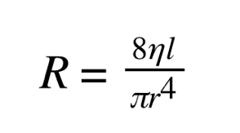

Where η is fluid viscosity, l is the length of the tube, and r is the (inner) radius of the tube. As a practical matter only r, the tube radius, is under physiological control; this is achieved by modulating the degree of contraction of the smooth muscles wrapped around the circumference of the airways (B&L[7], pages 456 - 458; West[10], pages 122 - 124). Recall also the material on resistance in the circulatory system in chapter 17 B&L[7].

1. Describe/discuss/explain how (increase/decrease/no change, mechanism(s)) forced expiration affects airway resistance.

Forced expiration, by reducing the volume of the thoracic cavity1, increases pressure on the lung, which increases the pressure surrounding airways, which reduces their diameter, thereby increasing their flow resistance. In addition, there is an internal pressure drop along airways engendered by flow (from alveoli toward the mouth/nose) that contributes to the airway transmural pressure (higher outside than inside) being enough to narrow, and at some point to close, airways (B&L[7], pages 460 - 461; West[10], pages 128 - 132).

1 Abdominal muscles contract, forcing abdominal contents to press upward on the diaphragm, pushing it into the thoracic cavity. Internal intercostals contract, drawing the ribs “down and in”, further reducing the volume of the thorax.

1. What are the local factors that affect ventilation/perfusion matching? How do (what is the mechanism by which) these factors exert their effects?

The term ***ventilation/perfusion matching*** refers to the (local) adjustments of blood flow and air flow to groups of alveoli so that the ratio of alveolar ventilation to perfusion is optimized (as much as possible) for the efficient exchange of gases (O2 and CO2) between alveolar air and pulmonary capillary blood. Put simply, it is the matching of alveolar ventilation and pulmonary capillary blood flow so that a respiratory unit has enough (not too much, not too little) air flow to allow for the proper addition of oxygen to, and the removal of carbon dioxide from, pulmonary capillary blood.

The local mechanisms are as follows:

Too much ventilation/insufficient blood flow

Local PCO2 decreases (decreasing local [H+]) and local PO2 increases. These changes:

1. increase the contraction of local airway smooth muscle, thereby increasing airway resistance, which reduces ventilation to better match the limited blood flow
2. decrease the contraction of local blood vessel smooth muscle, thereby reducing local vascular resistance, which increases local blood flow to better match the existing excess air flow. Note that the changes to ventilation and to perfusion occur at the same time, so that ventilation and perfusion meet in the middle, so to speak.

Too much blood flow/insufficient air flow  
Local PCO2 increases (increasing local [H+]) and local PO2 decreases.

These changes

1. decrease the contraction of local airway smooth muscle, thereby decreasing airway resistance, which increases local ventilation to better match the excess blood flow
2. increase the contraction of local blood vessel smooth muscle, thereby increasing local vascular resistance, which decreases local blood flow to better match the existing limited air flow. Note that the changes to ventilation and to perfusion occur at the same time, so that ventilation and perfusion meet in the middle, so to speak.

See Video 3, Slides 8 and 9.

1. With reference to respiratory physiology, what is FEV1?

During a measurement in which a person takes a maximal inspiration and then exhales maximally as fast as possible, FEV1 refers to the ratio of amount of air this person expelled during the first second over the total amount of air expelled by this person. In normal conditions FEV1 ≈ 75-80%.

1. Distinguish between *anatomic dead space* and *physiologic dead space*.

Physiologic = anatomic + alveolar dead space (Module 12, Video 1, Slide 8)

-  *Anatomic dead space* (nose, pharynx, larynx, trachea, bronchi, bronchioles, non- respiratory bronchioles) refers to the volume of the conducting airways. The conducting airways contain no alveoli and therefore do not participate in gas exchange (for a person of 150 pounds, volume of the anatomic dead space is about 150 ml).

-  *Alveolar dead space*: inspired air reaches alveoli that are ventilated but not perfused or poorly perfused (their capillaries do not get blood or they have thickened walls due to some disease) so these alveoli do not take part in gas exchange. Alveolar dead space typically is negligible in a healthy individual.

The physiologic dead space is always at least as large as the anatomic dead space, and in the presence of disease, it may be considerably larger.

1. Explain how (the mechanisms by which) oxygen is transported from atmospheric air to cells (in the body).

This process can be (arbitrarily) broken down into 4 distinct steps:

1. Air is moved both to and from the alveoli by bulk flow down a pressure gradient.
2. diffusion of O2 from alveolar air to pulmonary capillary blood
3. carriage of O2 in blood from pulmonary capillaries to tissue capillaries
4. diffusion of O2 from tissue capillaries to tissue cells.

Diffusion of O2 from alveolar air to pulmonary capillary blood

PO2 in alveolar air is ≈100 mmHg; in blood entering pulmonary capillaries it is ≈40 mmHg (B&L[7], Figure 23.8; VSL[14], Figure 13.21). So – there is a pressure gradient to drive oxygen, by simple diffusion, between the alveolar space and pulmonary capillary blood. The oxygen has to diffuse through the alveolar wall and the pulmonary capillary wall (Video 1, Slides 2, 3, 4). See also Video 1, Slide 5.

Carriage of O2 in blood from pulmonary capillaries to tissue capillaries  
Assuming no pathology, by the time blood passes through the pulmonary capillaries, the blood PO2 has equilibrated with the alveolar PO2 (B&L[7], Figure 23.8). Once O2 has diffused into pulmonary capillary blood it is carried dissolved (maybe ≈2%; in plasma and in the RBCs) or bound to hemoglobin (≈97-98%; in the RBCs) – see Video 2, Slide 2.

Diffusion of O2 from tissue capillary blood to tissue cells  
At the tissue capillaries there is a partial pressure gradient for oxygen favoring diffusion from tissue capillaries to tissue interstitium (and thence to cells) – see Video 2, Slide 2; VSL[14], Figure 13.21. As well, the affinity of hemoglobin for oxygen at the tissue capillaries is less than at the pulmonary capillaries because of the elevated temperature and PCO2 (Böhr effect) at the tissue capillaries WRT the pulmonary capillaries (Video 2, slides 8, 9). Once in the tissue interstitium, oxygen diffuses to and enters tissue cells.

1. Explain how (the mechanisms by which) carbon dioxide is transported from cells in the body to atmospheric air.

This process can be (arbitrarily) broken down into 4 distinct steps:

1. diffusion of CO2 from tissue cells to tissue capillary blood
2. carriage of CO2 in blood from tissue capillaries to pulmonary capillaries
3. diffusion of CO2 from pulmonary capillaries to alveolar air.
4. CO2 from the alveoli is blown into atm as we exhaled by a pressure gradient driving air out.

Diffusion of CO2 from tissue cells to tissue capillary blood  
At the tissue capillaries there is a partial pressure gradient for CO2 favoring diffusion (of CO2) from tissue cells to interstitium to tissue capillary blood (VSL[14], Figure 13.21; Video 2, Slide 3). As well, the affinity of hemoglobin for

CO2 is “high” because of the “low” partial pressure of oxygen (≈40 mmHg) in tissue capillary blood (Video 2, Slide 10). So – the diffusion of CO2 from the tissue cells to tissue capillary blood is favored.

Carriage of CO2 in blood from tissue capillaries to pulmonary capillaries

CO2 is carried in venous blood (from tissue capillaries to pulmonary capillaries) in 3 forms:

1. dissolved (in plasma and in RBCs)
2. as carbamino compounds (in plasma and in RBCs)
3. as bicarbonate ion (in plasma and in RBCs)

see Video 2, Slides 3, 4; West[10], Figure 6.5.

Diffusion of CO2 from pulmonary capillaries to alveolar air  
At the pulmonary capillaries there is a partial pressure gradient for CO2 favoring diffusion of CO2 from pulmonary capillary blood (PCO2 ≈46 mm Hg) to alveolar air (PCO2 ≈40 mmHg – see VSL[14], Figure 13.21). As well, the increase in PO2 that takes place in the pulmonary capillaries favors off-loading of CO2 from hemoglobin (Haldane effect, Video 2, Slide 10). Note also that the diffusion of CO2 from pulmonary capillary blood to alveolar air favors the reaction of bicarbonate ion to form CO2, which diffuses from RBCs to alveolar air – see Video 2, Slide 4.

1. Describe the effect(s) of increased temperature and acidity on the oxygen - hemoglobin saturation curve. Explain the physiologic significance of such effect(s).

Increased temperature and/or acidity (increased [H+]; lower pH) shift the hemoglobin – oxygen saturation curve to the right (Video 2, Slides 8, 9). This means that, at a given PO2, hemoglobin will bind less oxygen (WRT the un-shifted curve). The physiological significance is that, since the temperature and acidity of metabolizing tissue are both elevated, more oxygen is delivered to metabolizing tissue (right-shifted curve; increased temperature and acidity), where it is needed, then might otherwise be delivered had the curve not been right-shifted.

1. Where (anatomically) is the controller for respiratory rate and depth?

The controller for respiratory rate and depth is located in the brainstem, more specifically the medulla. There are two groups of neurons involved in the generation of the respiratory pattern:

* The dorsal respiratory group (DRG) located in the dorsomedial region of the medulla.
* The ventral respiratory group (VRG) located in the ventrolateral region of the medulla.

The neurons of the DRG primarily fire during inspiration and have input to the spinal motor neurons that activates respiratory muscles involved in inspiration – the diaphragm and external intercostal muscles.

The respiratory rhythm generator is located in the pre-Botzinger complex of neurons in the upper part of the VRG. The VRG is also composed of three cell groups:

* Rostral nucleau retrofacialis (exhalation)
* Caudal nucleus retroambiguus (exhalation)
* Nucleus para-ambiguus (inspiration)

1. Where (anatomically) are the sensors that provide input to the respiratory controller? What are the sensed variables?

There are three groups of sensors which provide input to the respiratory controller:

* *Central chemoreceptors* are located near the respiratory centers, situated near the ventral surface of the medulla, close to entry of VIII and XI cranial (in the retrotrapezoid nucleus (RTN) in caudal pons/rostral medulla). They are sensitive to a rise of PCO2 in the blood via associated changes in H+ concentration.
* *Peripheral chemoreceptors* are located in the aortic arch (and they are the aortic bodies) and in the carotid bifurcation, left and right, (they are the carotid bodies). They are monitoring increase in PCO2, H+ concentration and significantly decrease of PO2 (< 60mmHg).
* *Pulmonary mechanoreceptors* which include:

. sensors located in the upper airways (nasopharynx, pharynx). These sensors are stimulated by noxious substances which when inhaled will trigger “one-time event” like sneezing or coughing.

. sensors diffusely located through the lung parenchyma. They are fired in response to distension of the lung, and their activity is sustained with lung inflation.

. sensors located in the skeletal muscles driving respiration and in the tendon of these muscles. They respond to changes in the length and force of these muscles.

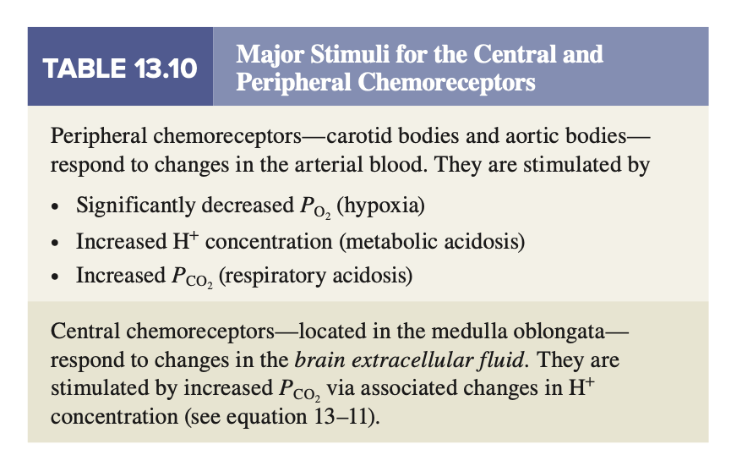

VSL[14] Table 13.10

1. Differentiate between pulmonary minute ventilation and alveolar minute ventilation.

* Pulmonary minute ventilation: is the amount of air delivered to the lungs per minute; it is equal to the tidal volume multiplied by the respiratory rate.
* Alveolar minute ventilation: is the amount of air delivered to the alveoli per minute: it is equal to the (tidal volume - anatomic dead space volume) multiplied by the respiratory rate, in breaths per minute.

1. With reference to respiratory physiology, differentiate between an anatomic shunt and a physiological shunt.

* *Anatomic shunt* or right-to-left shunt, it happens usually in the heart, and causes mixed venous blood to bypass ventilated alveoli and mixed with oxygenated blood resulting in varying degrees of arterial hypoxemia.
* *Physiological shunt*, an intrapulmonary defect in which mixed venous blood perfuses unventilated alveoli.

The net result of a shunt either anatomic or physiological is a decrease in arterial PO2.

In both shunts, the PaCO2 is not usually increased even though the shunted blood has an elevated level of CO2. The reason for this is that the central chemoreceptors respond to any elevation in CO2 with an increase in ventilation and reduce PaCO2 to the normal range. If the hypoxemia is severe, the increased respiratory drive secondary to the hypoxemia increases the ventilation. Hypoxemia responds poorly to inspired O2.

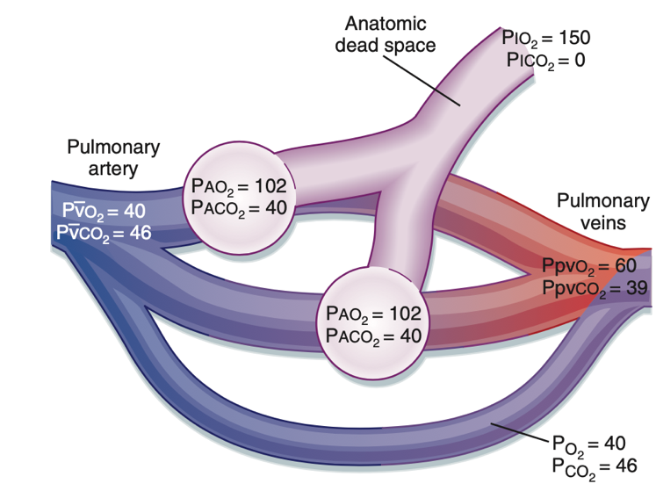

Anatomic shunt - Fig.23.9 B&L[7]

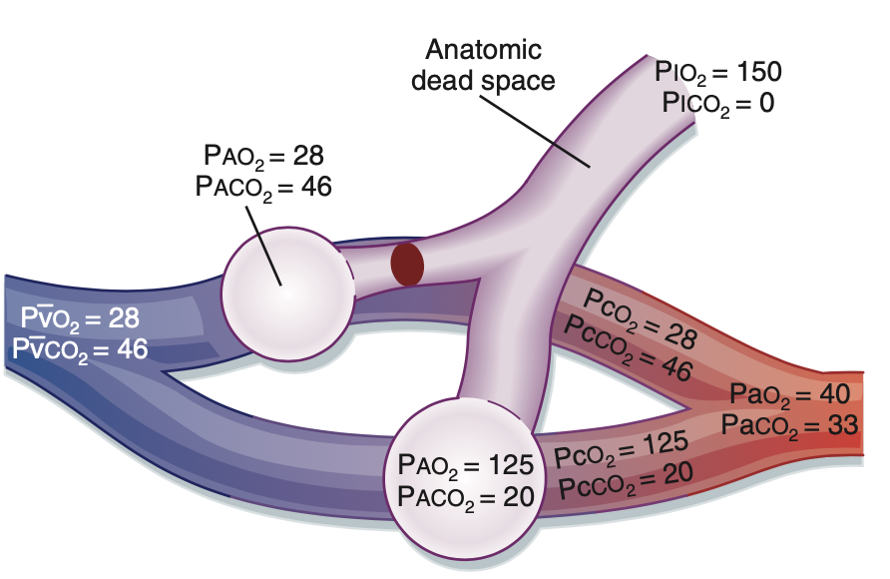

Physiological shunt - Fig.23.10 B&L[7]

1. Write an equation for alveolar minute ventilation as a function of respiratory rate, tidal volume, and anatomic dead space for an adult at rest. Provide nominal “normal” values (or a range of values) for each parameter.

Alveolar minute ventilation: the amount of air delivered to the alveoli per minute:

= VT x f – VD x f = -

Where:

* VT (mL) = tidal volume, average-sized adult tidal volume is 500mL
* VD (mL) = anatomic dead space, normal value is about 150 mL
* f: respiratory frequency or number of breaths per minute, normal respiration rates for an adult person at rest range from 12 to 16 breaths per minute.
* : alveolar minute ventilation (mL/min),

“normal” value is then (500-150) x 12 to (500-150) x 16 = 4200 mL/min to 5600 ml/min

1. Does oxygen bound to hemoglobin affect the partial pressure of oxygen in the blood (yes/no)? Briefly explain your response.

PO2 mainly depends on the % saturation of oxygen bound to hemoglobin, and the oxygen dissolved but only a small amount of oxygen is dissolved. Each hemoglobin molecule contains four subunits, and each subunit can combine with one molecule of oxygen. And the reactions of the four subunits occur sequentially, with each combination facilitating the next one so the more oxygen bound, the more saturated hemoglobin becomes, and the higher the partial pressure of oxygen becomes until finally you reach a point of maximum saturation. And an increase of oxygen saturation at that point, does not increase the PO2 (asymptotic behavior of the part of the O2 dissociation curve).

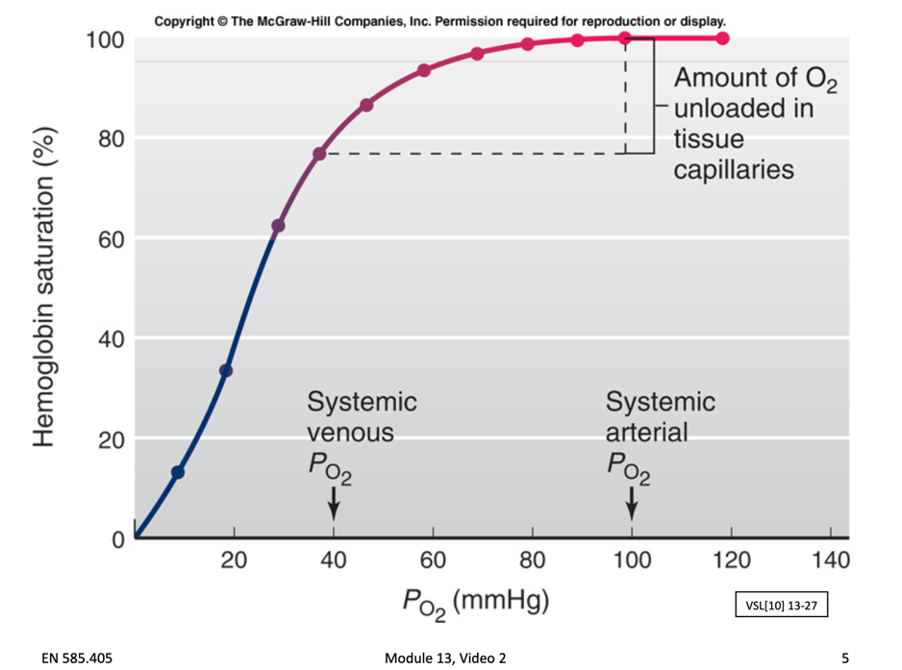

**O2 dissociation curve (sigmoid)**

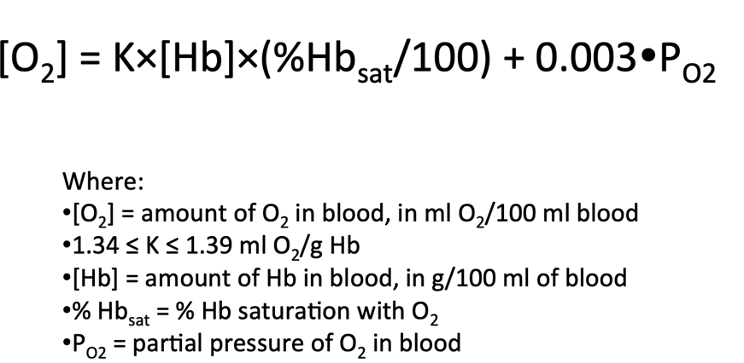

Module 3 – Video 2 – Slide 7 – Oxygen capacity depends mostly of oxygen saturation (%Hbsat)

1. What would be the effect on the at-rest breathing of a nominally “normal” adult if their nose was clamped closed and they were required to mouth-only breathe through a gas-impermeable cylindrical tube 2 inches in diameter and 3 feet long? Discuss/explain briefly.

Volume of the tube:

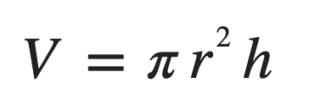

Then for r=1 inch, h=3 feet = 3 x 12 = 36 inches the volume of the is V = 3.14 x 1^2 * 36 about 113 cubic inch or 113 x 16.4 ≈ 1854 mL. The air filling the tube represents the space not delivered to the alveoli ventilation for gas exchange and the volume of the tube adds up to this person anatomic dead space. In a “normal” adult the anatomic dead space is about 150ml, the anatomic dead space has increased by 11-fold! This very large increase will reduce considerably the alveolar ventilation and tidal volume will need also to be largely increased in the same proportion. In addition, since airway resistance is proportional to the fourth power of the radius of the tube which has rather small radius compared to the mouth the airway resistance will also very largely increase.

1. Describe/discuss/explain the mechanism(s) by which a “low” blood pO2 at the carotid bodies becomes an afferent signal that will affect respiration. Where does this afferent signal go to (location, structure, etc.)? A drawing/sketch might be helpful.

The carotid bodies consist of glomus cells which are sensitive to “low” blood PO2 (arterial PO2). A low blood PO2 in the close vessel closes the cell potassium channels which trigger a depolarization of the cell which, then opens voltage-gated Ca2+ allowing calcium entry into the cell then releasing of neurotransmitters into the extracellular cleft (exocytosis of neurotransmitters). The neurotransmitters bind then to receptors on the post-synaptic nerves which fire and transmit the afferent signal to the respiratory centers in the medulla through the carotid sinus nerve which then cause an increase in ventilation.

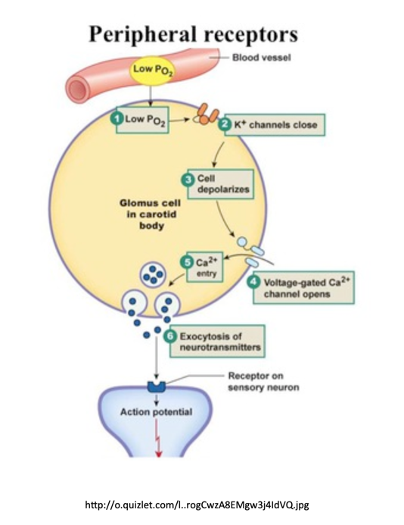

**Module 14 – Video 2, Slide 4**

1. Describe/discuss/explain the feedback loops between an increase in pCO2 in blood plasma and a change in ventilation. A flow chart/diagram would likely be helpful.

The peripheral chemoreceptors are stimulated by the increased arterial H+ concentration resulting from the increased pCO2. At the same time, CO2 diffuses into the cerebrospinal fluid from the blood vessels, where carbon dioxide reacts with water to give bicarbonate and hydrogen ions, the increase H+ stimulates the central chemoreceptors. Signals from both the peripheral and central chemoreceptors stimulate the medullary respiratory neurons which fire neurons to diaphragm and, inspiratory intercoastal muscles if necessary, to increase ventilation. The increase in ventilation leads to an increase in alveolar ventilation and a decrease in pCO2. This feedback loop is maintained until the pCO2 is restored to its “normal” value.

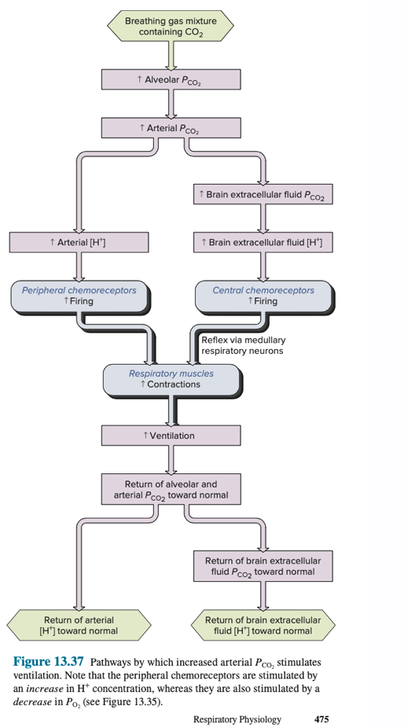

B&L[7]

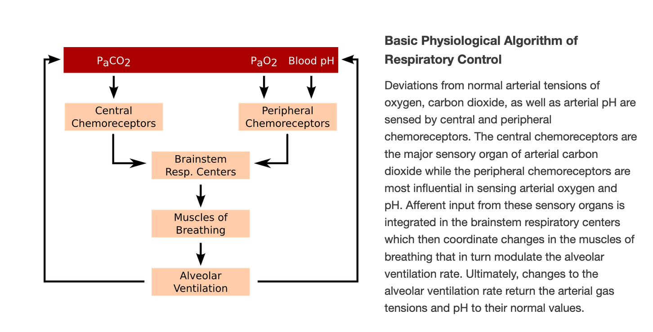

From <http://www.pathwaymedicine.org/integrated-respiratory-control>

1. What is the signal that is detected by central chemoreceptors (in the medulla), that is the indicator of an increase in blood pCO2?

The central chemoreceptors do not directly detect the arterial CO2 increase. Instead, they detect decreases in the CSF pH.

Arterial CO2 diffuses past the blood brain barrier, into the CSF, and is converted by carbonic anhydrase to carbonic acid (H2CO3) which is the converted into bicarbonate and a free hydrogen ion. When arterial carbon dioxide increases above normal, CSF pH decreases which stimulate the central chemoreceptors.

An increase in the partial pressure of oxygen in arterial blood will result in:

1. A reduction in the rate of firing of nerve impulses on the phrenic nerve.
2. An increase in the firing rate of central chemoreceptors.
3. An increase in tidal volume.
4. An increase in physiological dead space.

# There are specialized cells in the carotid bodies that release a neurotransmitter in response to low pO2

1. in carotid artery blood. A likely cellular level mechanism for this is that the low pO2 causes ...
2. The opening of a Cl- channel in the cell membrane.
3. The closing of a T-type Ca2+ channel in the cell membrane.
4. The opening of a K+ channel in the cell membrane.
5. None of the above mechanisms are involved in the transduction of low carotid artery pO2into a release of neurotransmitter from cells in the carotid bodies.

# Where, within the central nervous system, are the major regulatory centers for respiration, especially for inspiration, located?

# Spinal cord

# Cerebellum

# Pons

# Medulla

# Cerebral cortex

# An increase in the partial pressure of CO2

1. in blood ...
2. Directly stimulates central chemoreceptors to increase ventilation.
3. Increases the amount of O2 carried by hemoglobin when it is saturated with oxygen.
4. Indirectly stimulates central chemoreceptors to increase ventilation.
5. Suppresses contraction of the diaphragm.

# Imagine a blood substitute in which the binding of O2 to its carrier protein is not altered by pH. How would the use of such a blood substitute affect breathing? Describe/discuss/explain briefly.

pH of the blood determines the loading/unloading of oxygen from the blood:

at the tissue capillaries, CO2 concentration is higher, so the pH increases which results in a lower affinity of hemoglobin for oxygen enhancing the release of oxygen off the hemoglobin and providing oxygen to the cells. In the lungs, CO2 concentration is lower, pH increases which enables the binding of oxygen to hemoglobin.

If the blood substitute is not altered by pH then the substitute will not load or unload oxygen, the cells will die by not receiving any oxygen.

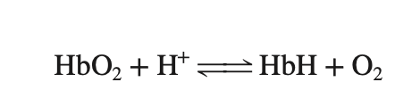

VSL[14] p.471

# Consider a normal adult breathing at rest. Of the oxygen that binds to hemoglobin as blood moves through the pulmonary capillaries, what percentage of that oxygen remains bound to hemoglobin as blood leaves the tissue capillaries on its way back to the lungs? 0% 25% 50% 75%